  

**MATHEMATICS**

**Specialist Units 3 & 4**

**Test 3 – Vectors**

**Semester 1 2019**

# 

**Section Two – Calculator Assumed**

Time allowed for this section

Working time for this section: 30 minutes

Marks available: 30 marks

## Material required/recommended for this section

##### To be provided by the supervisor

This Question/Answer booklet

Formula sheet

##### To be provided by the candidate

Standard items: pens, pencils, pencil sharpener, eraser, correction fluid, ruler, highlighters

Special items: drawing instruments, templates, notes on one unfolded sheet of A4 paper, and up to three calculators satisfying the conditions set by the Curriculum Council for this course.

## Important note to candidates

No other items may be used in this section of the examination. It is **your** responsibility to ensure that you do not have any unauthorised notes or other items of a non-personal nature in the examination room. If you have any unauthorised material with you, hand it to the supervisor **before** reading any further.

1. (7 marks: 5, 2)  
   The line that passes through point A, position vector $〈2, -1, 3〉$, is perpendicular to the plane

$x-y+2z=27$.

1. Determine the point of intersection of the line and the plane.
2. Calculate the shortest distance from the point A to the plane.
3. (12 marks: 1, 3, 4, 4)

A baseball player strikes a ball with initial velocity ms-1, the bat connects with the ball at $\left(\begin{matrix}0.3 \\ 1.3\end{matrix}\right)$ m and acceleration due to gravity is -9.8 ms-2.

1. The ball was hit at a speed of 32 ms-1at an angle of 60o above the horizontal. Calculate the values of $a$ and $b$.
2. Find the speed of the ball after 3 seconds.
3. A fence 3 m tall is located 106 m horizontally from the baseball player. Will the ball clear the fence? Justify your answer.

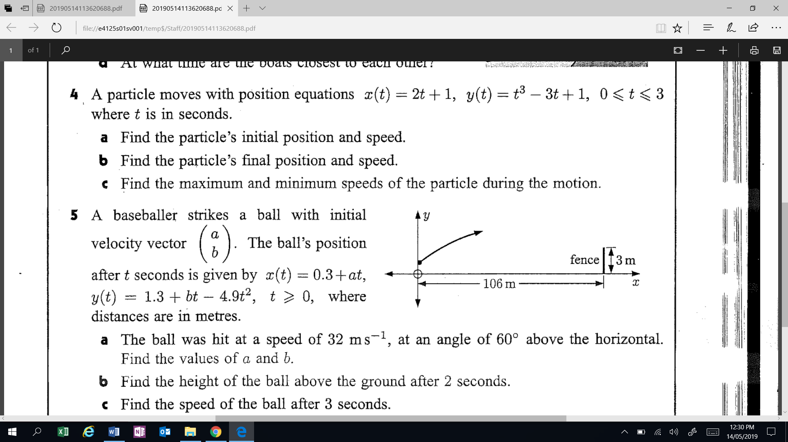

1. How far has the ball travelled from first being hit until it strikes the ground or the fence, whichever comes first?
2. (4 marks)

Determine the vector equation of the sphere with diameter AB. Point A is located at position vector $〈-1, 4, -3〉$ and the position vector of point B is $〈4, -2, 1〉$.

1. (7 marks)

The vector equation a plane is given by $r.\left(i-7j+5k\right)=5$. The vector $2i+j+k$ lies on the plane. Determine a second vector on the plane which is at an angle of 60 degrees to the vector $2i+j+k$**.**

**End of Test**

**This page has intentionally been left blank**

You may use this space to extend or re-attempt an answer to a question or questions and should you do so then number the question(s) attempted and cross out any previous unwanted working.